

The Hive Daily Routine
7.45 am Early Start
8.00 – 9.00 am Breakfast
9.00 am Doors Open for morning children to arrive
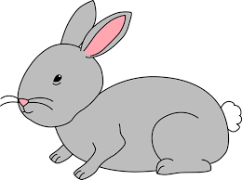

9.20 - 9.30 am Family Time
9.30 am Play to Learn (Garden opens)
9.45 – 10.45 am Snack bar open
11.40 am Reset inside and outside
11.50 am Story time
11.55 am Some children transition to go home at 12pm


11.55 – 12.50 pm Lunch
12.50pm Some children transition to go home at 1pm
1.00 pm Doors open for afternoon children to arrive
1.15 - 1.25 pm Family Time
1.25 pm Play to Learn (Garden opens)
1.45 – 2.45 pm Snack bar open
3.40 pm Tidy up inside and outside (music to prompt)
3.45 pm Story time
3.55pm Some children transition to go home at 4pm

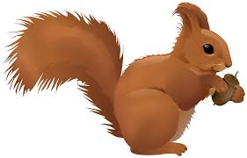
4.00 – 6.00pm Tea and evening session
6.00pm Last Pick Up – Home time!


